# HiJack mega HW Starter Kit User Manual

|  |  |  |  |
| --- | --- | --- | --- |
| Version | Date | Initial | History |
| 0.01 | 2012-12-21 | Ren Kai | Origination |

1. Evaluation board

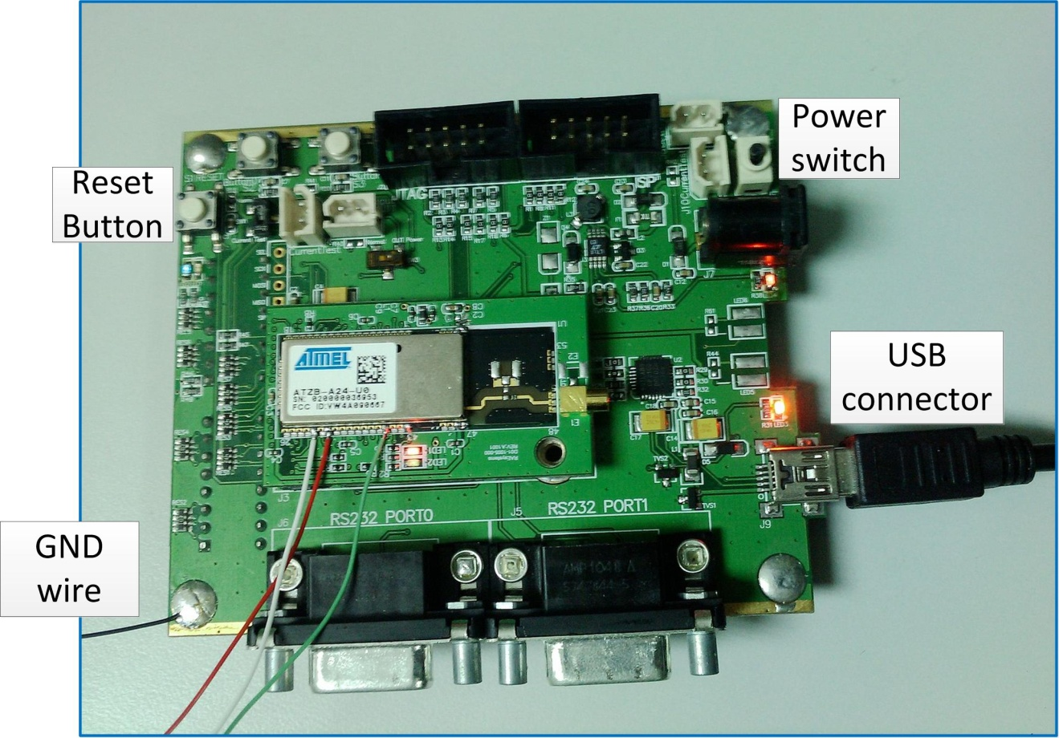

Before you connect this board with your PC using USB cable, please install CP2102 USB TO UART DRIVER, it can emulate a virtual com port like this COM10:

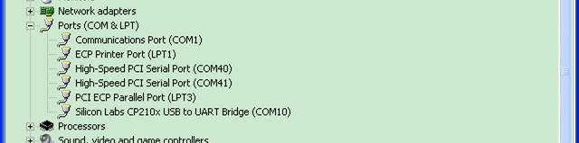

***Caution: there are two DIP switch on the board, DON’T touch them.***

1. Encode module

There are two encode module, although they are different on the appearance, they have same function.

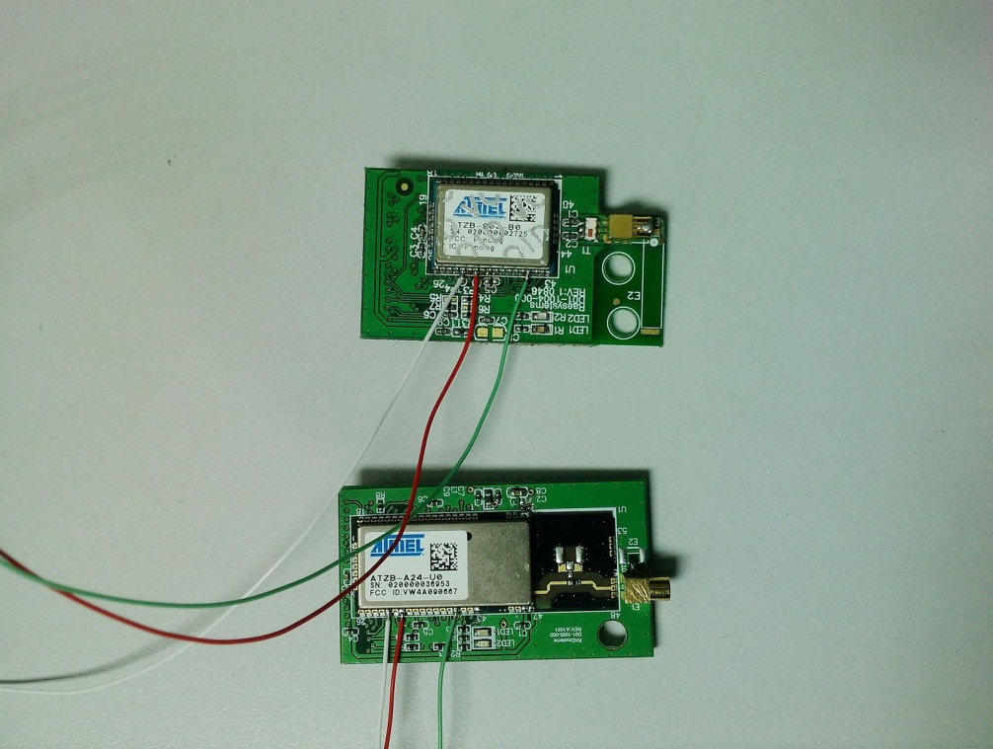

Every module have three wires, **RED WIRE** is module encode output, you should use this wire for android decoding.

1. Upgrade tool

We can guarantee that our encode firmware is clean, maybe module user need to upgrade module’s firmware for fixing bug, below is upgrade tool.

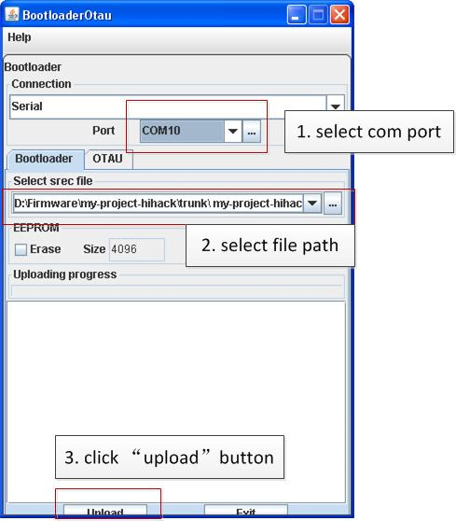

After you power on the board and module, finish usb2usart emulation, you should do as follow to upgrade:

1. Select corresponding com port(emulated).
2. Select firmware, output file format is Motorola-s28, *.srec.
3. Click “upload” button.
4. Then press reset button on the board within 30 seconds, upgrade can start.